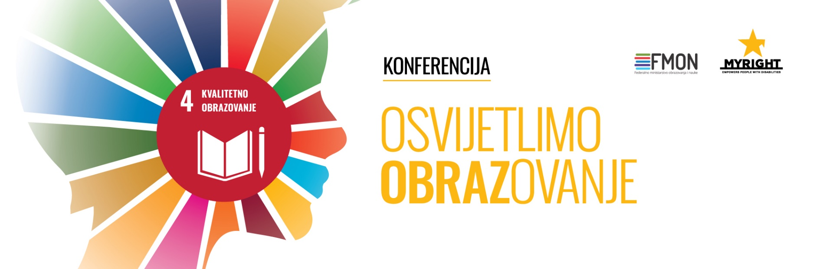

Sarajevo, 04.10.2021.
Conference on quality inclusive education "Let's illuminate EDUCATION" ended:
Where is Bosnia and Herzegovina on the path to achieving goal 4 of the Sustainable Development Program?
The conference on quality inclusive education in the context of achieving goal 4 of the Sustainable Development Program in Bosnia and Herzegovina entitled "Let's illuminate EDUCATION" was held today in Sarajevo. The conference was organized by MyRight-Empowers people with disabilities and the Federal Ministry of Education and Science to update the state of inclusive education for children and youth with disabilities and enable the building of stronger links between different actors in education in BiH. The conference was organized as a hybrid event where all speakers were presenting live, and the audience followed the conference via the zoom platform that gave the audience the opportunity to ask questions and give comments.
The conference was attended by a large number of representatives of education authorities, international and domestic NGOs, academia and organizations of persons with disabilities to assess Bosnia and Herzegovina's progress towards Goal 4 of the Sustainable Development Program and identify what still needs to be done to achieve this goal.
The conference was opened by Nafisa Baboo, the renowned expert in the field of inclusive education who is a longtime associate of MyRight from the partner organization Light for the World. In her presentation, she shared her own experiences of working on building inclusive education in different parts of the world. She paid special attention to the challenges that are inevitably faced by all participants in this process of building educational systems which should be adapted to the abilities of each individual child with disabilities.
Representatives of the Ministry of Civil Affairs, the Federal Ministry of Education and Science, the Ministry of Education of the Republika Srpska and the OSCE, and the Council of Europe, presented in the plenary part of the conference their contribution to establishing quality and equitable inclusive education and inclusion of this the most vulnerable group of society in the mainstream school system.
After the plenary part of the conference, representatives of the academic community and NGOs and people with disabilities who are best acquainted with the situation in education and what needs to be improved, continued their work through panel discussions – one of panels had subject on competencies that teachers must have as key actors in the education process so they can achieve planned learning outcomes of children with disabilities. Other panels discussed support systems which are crucial for full inclusion, and the quality of education that must train young people with disabilities for their future jobs so that they can be employed, as the only and safe way to reduce poverty.
"It is very important that all levels of government, international organizations, the non-governmental sector, but also people with disabilities, as the most invited to talk about inclusion, communicate and exchange experiences on quality inclusive education, in one place, " said Binasa Goralija, regional coordinator for MyRight for Europe, adding that it was high time for a conference like this with a hope that such conference would become regular.
The conference produced a set of conclusions, that will serve as recommendations and priorities for future activities of all relevant actors in education in order to accelerate the process of achieving quality inclusive education as a condition for meeting goal 4 of the Sustainable Development Program.

